**Nama : Aldi Septiyanto**

**NIM : 20210140002**

**Kelas : A**

**Matkul : Pengembangan Desain Web**

**EXERCISE 2 PDW**

**Nb. Code index.html**

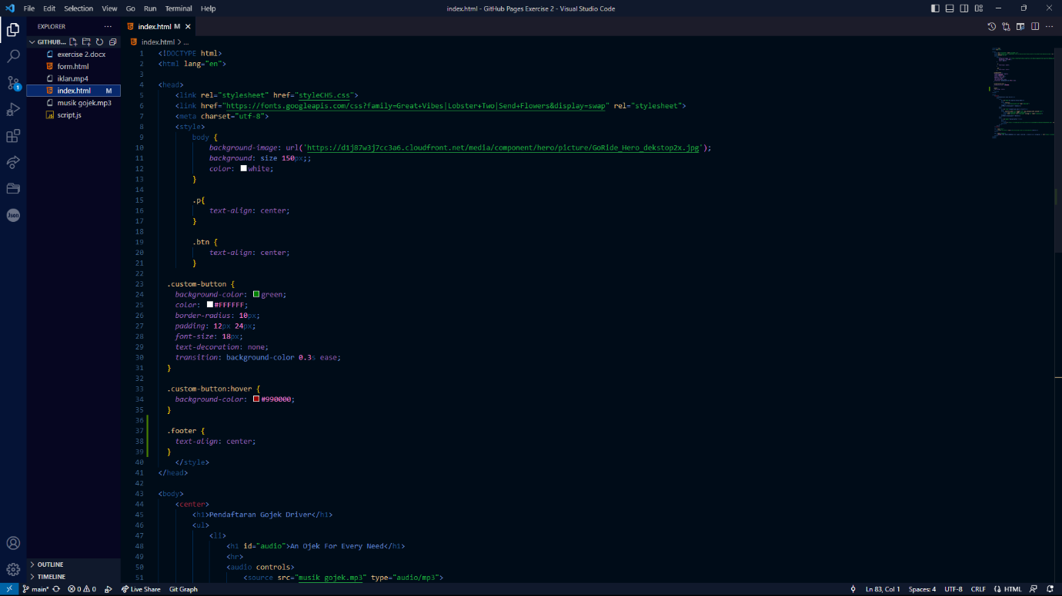

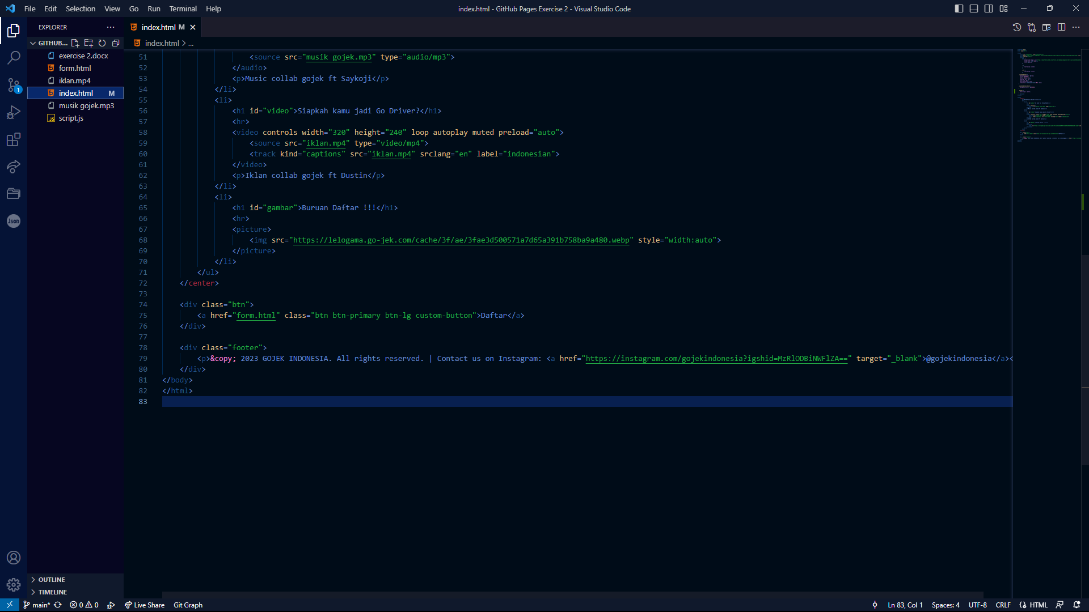

**Nb. Code form.html**

**Nb. Code script.js**

**Nb. Run Code**

*Link github:*